简介:
This product is positioned as a compact separated USB endoscope camera for projects that need a small camera head, integrated illumination, and more reliable use in environments where Waterproof and Dustproof protection matters. It is especially suitable for inspection devices that need practical USB output together with a protected optical head.

Introduction:
This is a Professional Borescope separated USB endoscope camera module designed for products that need a compact 3.9mm camera head, integrated LED illumination, and reliable Waterproof and Dustproof performance. Built around the OmniVision OV9734 CMOS sensor, it supports 720P imaging at up to 30fps through a USB-5P interface at USB 2.0 speed. With a Steel Shell, 4 integrated LEDs, IP67 protection, and a wide-angle direction of D95° / H85° / V43.5°, it is a practical choice for endoscope, borescope, and close-range inspection applications.
视频：https://youtu.be/mq5d1CDICik

Features:
• OmniVision OV9734 CMOS Sensor
Uses the OmniVision OV9734 CMOS sensor for HD endoscope imaging in compact devices that need stable close-range image capture.
• 720P Imaging up to 30fps
Supports 720P image output at up to 30fps, giving endoscope and inspection products practical HD performance through a USB-based connection.
• 3.9mm Camera Head with Steel Shell
The 3.9mm camera-head diameter and integrated Steel Shell make it suitable for compact endoscope and borescope products that need stronger mechanical protection.
• Integrated 4-LED Illumination
Uses 4 integrated LEDs to improve visibility in darker or enclosed inspection environments where external lighting is limited.
• IP67 Waterproof and Dustproof Direction
The IP67 protection level makes this module more suitable for damp, dusty, or harder-use environments than a standard non-protected endoscope camera.
• Separated USB Endoscope Structure
The separated design gives OEM products more flexibility in camera-head placement while keeping host-side USB integration practical.
• USB-5P Interface with USB 2.0 UVC
Supports USB-5P connection, USB 2.0 speed, UVC protocol, and YUV / MJPEG output for straightforward host-side integration.

Application of Endoscope Camera Module:
• Waterproof Endoscope Devices
This module is suitable for endoscope products that need a compact camera head with Waterproof and Dustproof protection for more demanding environments.
• Industrial Borescope and Inspection Tools
Its Steel Shell, integrated LEDs, and separated structure make it a practical fit for borescope and visual inspection tools used in tighter spaces.
• Maintenance and Service Imaging
It is suitable for devices used in service, maintenance, and close-range visual inspection tasks where durability and low-light visibility both matter.
• USB-Based Visual Examination Systems
USB 2.0 UVC output makes it easier to integrate into compatible host devices for inspection and visual examination use.

Product Details:
Product Name | 3.9mm Diameter LED Endoscope Camera Module
Sensor | OmniVision OV9734 CMOS Sensor
Resolution | 1280x720
Frame Rate | 30FPS
Focal Length | 1.08mm
Focusing Range | 10~100mm
F.NO | 4.0
View Angle | D95°*H85°*V43.5°
LED | 4pcs 0402
Diameter | 3.9mm
Shell | Steel Shell
Protection Direction | IP67 Waterproof and Dustproof
Output Format | YUV/MJPEG
Interface | USB 2.0, UVC

Customization Options:
LED Type and Lighting Direction
LED type and illumination direction can be reviewed for projects that need a different lighting behavior from the standard 4-LED configuration.
Lens Type and Viewing Angle
Lens type and viewing angle can be discussed according to the final inspection distance, coverage requirement, and device use environment.
Separated Structure Review
The separated module direction can be evaluated according to the final device layout, cable path, and installation requirement.
Shell and Integration Review
Shell-related integration and assembly direction can be reviewed according to the final device structure and protection requirement.
USB SDK and Testing Support
For most USB-based modules, SDK support and dedicated test software can usually be provided for development and evaluation.
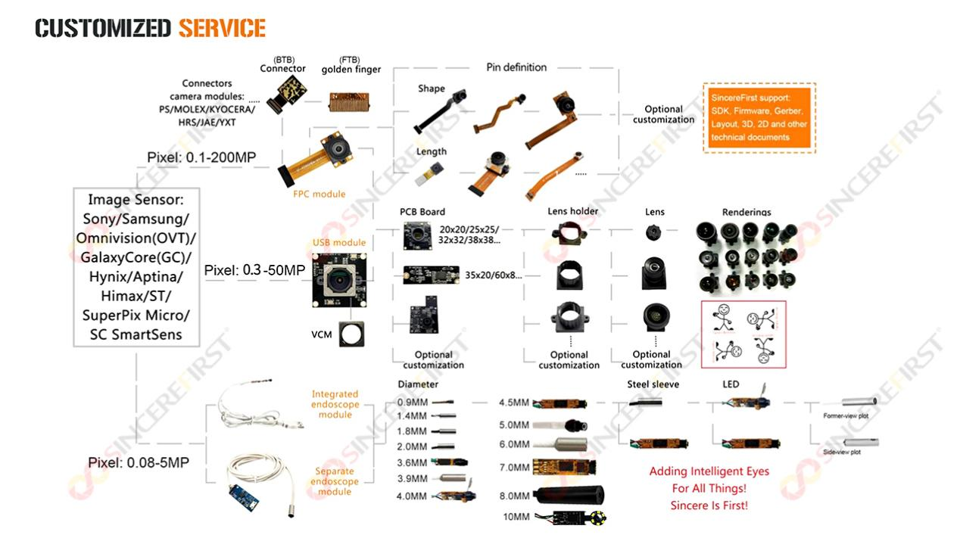

FAQ:
What is SF-C1019USB-D3.9-PRO V1.2 designed for?
It is designed for compact endoscope and borescope products that need Waterproof and Dustproof protection, integrated lighting, and practical USB output.

Does this module use a Steel Shell?
Yes. The camera head uses an integrated Steel Shell for a more protected optical structure.

Is this module Waterproof and Dustproof?
Yes. This product direction is positioned with IP67 Waterproof and Dustproof protection.

How many LEDs are integrated?
This module uses 4 integrated LEDs for close-range illumination support.

Does it support USB 2.0 UVC output?
Yes. It supports USB-5P connection, USB 2.0 speed, UVC protocol, and YUV / MJPEG output.

Is this module suitable for borescope applications?
Yes. Its compact 3.9mm camera head, Steel Shell, and Waterproof / Dustproof direction make it suitable for borescope and inspection products.

Can the optical direction be customized?
Yes. Lens type, viewing angle, and lighting direction can be reviewed according to the final application.

